**TASK 1:**

**CODE:**

OUTPUT:

**TASK 2:**

CODE:

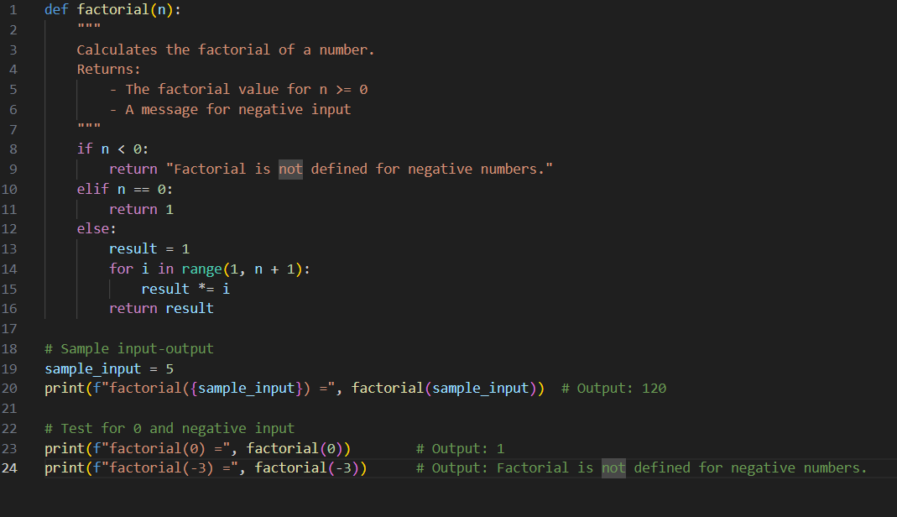

OUTPUT:

TASK3

CODE:

OUTPUT:

TASK 4:

OUTPUT:

TASK 5:

CODE:

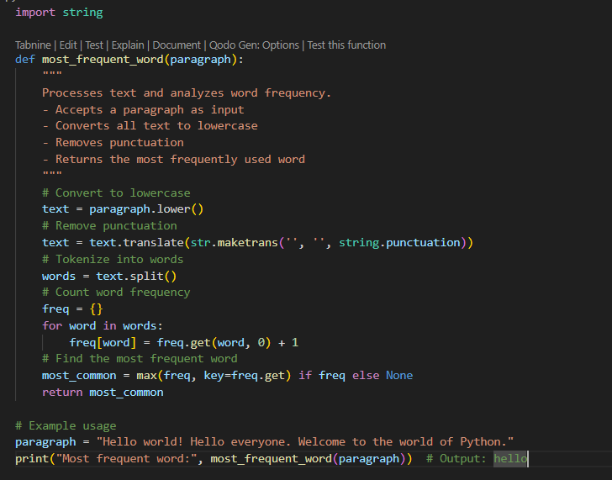

OUYPUT:

